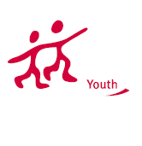
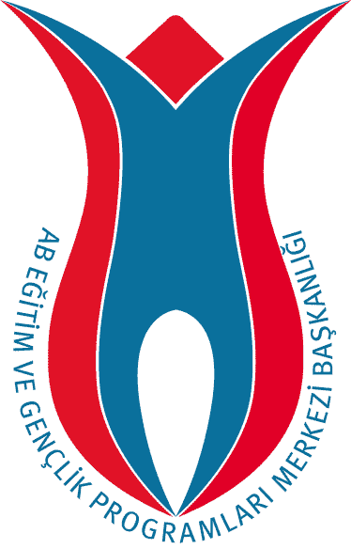
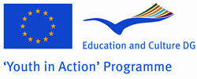
TURKISH NATIONAL AGENCY

PARTNER REQUEST FORM
Please read below before filling in the form:
1- This form should be sent to the email address: partneryouth@ua.gov.tr
2- Only forms written / typed in English is accepted.
3- To mark a check box, please double click on it and select “checked” as the default value, and click OK.
4- Please do not remove any tables or explanations.

About the Organization and Contact Person
Name of the Organisation / Group |  |  | DICLE UNIVERSITY EU PROJECT COORDINATION OFFICE
Address | Dicle University, Foreign Language Teaching Application And Research Centre / 4th floor
City | DİYARBAKIR | Country |  | TURKEY
Telephone 1 | +90 04122488452 | Telephone 2 |  | +90 04122488452
Email 1 | umut051453@yahoo.com | Email 2 |  | alperkskn@yahoo.com
Fax | +90 04122488298 | Website
Name of the Contact Person |  | Ümit Öztürk
Telephone 1 | 05544431736 | Telephone 2 |  | 05555461654
Email 1 | umut051453@yahoo.com | Email 2 |  | alperkskn@yahoo.com

2. About The Project
Project Name: |  | INNOVATIVE AND YOUNG STEPS TOWARDS MORE DEMOCRATIC WORLD

Type of the Project
 | Action 1.1 - Bilateral |  |  | Action 1.1 -Trilateral |  |  | Action 1.1 - Multilateral
 | Action 1.2 - Transnational |  |  | Action 1.3 – Youth Democracy Projects |  |  | Action 3.1 – Youth Exchanges
 | Action 3.1 – Training & Networking |  |  | Action 4.3 |  |  | Action 5.1

If It is Action 4.3 or 3.1 Training & Networking, then the Activity No:

(1- Job Shadowing, 2- Feasibility Visit, 3- Evaluation Meeting, 4- Study Visit,

5- Partnership-Building, 6- Seminar, 7- Training Course, 8- Networking)
Activity venue/place |  |  | DIYARBAKIR |  | City |  | DIYARBAKIR
 |  |  |  |  | Country |  | TURKEY
Activity start date |  |  | 9 /11 / 2009 |  | End date |  | 16/ 11 /2009
Aim and Objectives
With this project we want to deal with EU youth’s representation problem.They complain that they aren’t represented democratically enough to deal with their problems by the policy makers.So they sometimes try to solve their represantation problems illegally.Even they sometimes form some illegal groups for this.
During the project different youth groups will come together and they will form a representative democracy council and they will represent some of their countries’ ministers and members of parliament.They will try to analyze and find solutions to youth problems with a different point of view and perspective.And this will help them to gain empathy.
Planned activities
During the Project youth groups will organize forums to analyze and discuss the youth problems as the representatives of their countrys’ policy makers and they will try find solutions to the problems. They will carry out so many different activities ;such as, questionnarie, preparing reports of results, workshop studies, evaluation of the days and activities, playing sketchs based on democracy concept and watching film related with youth problems and democracy concept, organizing stants to introduce countries etc.
Also lots of cultural activities will be carried out.The Project will start with a city tour ( Huge ramparts, Mosques, Churches etc. will be visited) and university tour. Especially some historicaly famous places will be visited ; such as, Ergani Virgin Mary Church and remains left from Neolithic Age, visiting Eğil and historıcal places, ferry tour, Malabadi Bridge, Batman (Hasankeyf), Gazi Pavilion etc

3. About The Group / Participants
Gender Balance | Male |  | Female | Total
Gender Balance | 16 |  | 8 | 16
Age Range | 13-14 |  | 15-17 | 18-25 |  | 26-30
Age Range |  |  |  | 24
General Profile of the Group |  | Young people |  |  | Unemployed young people
General Profile of the Group |  | Students |  |  | Youth workers
General Profile of the Group |  | Apprentices /young workers |  |  | Ethnic minorities
General Profile of the Group |  | Disabled |  |  | Disadvantaged youth
General Profile of the Group |  | Youngsters with special needs |  |  | Other

4. Which countries would you like to have partner from?
Our project is open to all program countries
Our project is open to all program and partner countries
I would like to write the list of countries (separated by comas):

5. Any Additional Information
We need two different groups from the same program country, (age btw. 20-25 is better)

